Chapter Six

Physics

ELECTROMAGNETIC INDUCTION

##### INTRODUCTION

Electricity and magnetism were considered separate and unrelated phenomena for a long time. In the early decades of the nineteenth century, experiments on electric current by Oersted, Ampere and a few others established the fact that electricity and magnetism are inter-related. They found that moving electric charges produce magnetic fields. For example, an electric current deflects a magnetic compass needle placed in its vicinity. This naturally raises the questions like: Is the converse effect possible? Can moving magnets produce electric currents? Does the nature permit such a relation between electricity and magnetism? The answer is resounding yes! The experiments of Michael Faraday in England and Joseph Henry in USA, conducted around 1830, demonstrated conclusively that electric currents were induced in closed coils when subjected to changing magnetic fields. In this chapter, we will study the phenomena associated with changing magnetic fields and understand the underlying principles. The phenomenon in which electric current is generated by varying magnetic fields is appropriately called *electromagnetic induction*.

When Faraday first made public his discovery that relative motion between a bar magnet and a wire loop produced a small current in the latter, he was asked, “What is the use of it?” His reply was: “What is the use of a new born baby?” The phenomenon of electromagnetic induction

204

## Ele ctromagnetic Induction

JOSEPH HENRY (1797 – 1878)

is not merely of theoretical or academic interest but also of practical utility. Imagine a world where there is no electricity – no electric lights, no trains, no telephones and no personal computers. The pioneering experiments of Faraday and Henry have led directly to the development of modern day generators and transformers. Today’s civilisation owes its progress to a great extent to the discovery of electromagnetic induction.

##### THE EXPERIMENTS OF FARADAY AND

**HENRY**

The discovery and understanding of electromagnetic induction are based on a long series of experiments carried out by Faraday and Henry. We shall now describe some of these experiments.

*Experiment 6.1*

Figure 6.1 shows a coil C1**\*** connected to a galvanometer

G. When the North-pole of a bar magnet is pushed

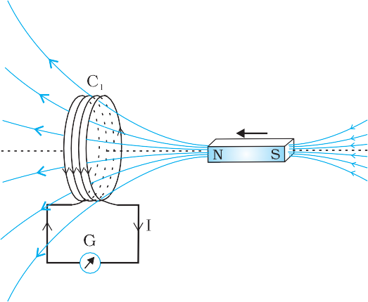towards the coil, the pointer in the galvanometer deflects, indicating the presence of electric current in the coil. The deflection lasts as long as the bar magnet is in motion. The galvanometer does not show any deflection when the magnet is held stationary. When the magnet is pulled away from the coil, the galvanometer shows deflection in the opposite direction, which indicates reversal of the current’s direction. Moreover, when the South-pole of the bar magnet is moved towards or away from the coil, the deflections in the galvanometer are opposite

to that observed with the North-pole for similar movements. Further, the deflection (and hence current) is found to be larger when the magnet is pushed towards or pulled away from the coil faster. Instead,

when the bar magnet is held fixed and the coil C1 is moved towards or away from the magnet, the same effects are observed. It shows that *it is the relative motion between the magnet and the coil that is*

*responsible for generation (induction) of electric current in the coil*.

### Experiment 6.2

In Fig. 6.2 the bar magnet is replaced by a second coil C2 connected to a battery. The steady current in the coil C2 produces a steady magnetic field. As coil C2 is

**Josheph Henry [1797 – 1878]** American experimental physicist professor at Princeton University and first director of the Smithsonian Institution. He made important improvements in electro- magnets by winding coils of insulated wire around iron pole pieces and invented an electromagnetic motor and a new, efficient telegraph. He discoverd self-induction and investigated how currents in one circuit induce currents in another.

**FIGURE 6.1** When the bar magnet is pushed towards the coil, the pointer in the galvanometer G deflects.

**\*** Wherever the term ‘coil or ‘loop’ is used, it is assumed that they are made up of conducting material and are prepared using wires which are coated with insulating material.

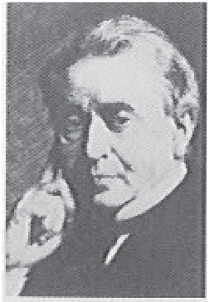

###### 205

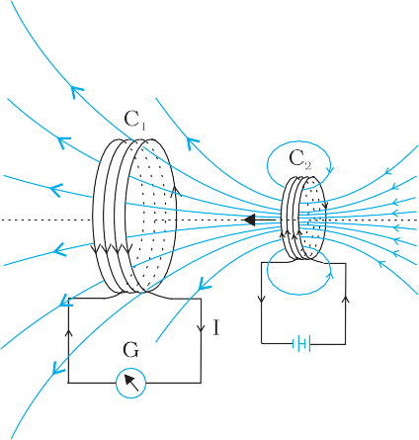

**FIGURE 6.2** Current is induced in coil C due to motion

moved towards the coil C1, the galvanometer shows a deflection. This indicates that electric current is induced in coil C1. When C2 is moved away, the galvanometer shows a deflection again, but this time in the opposite direction. The deflection lasts as long as coil C2 is in motion. When the coil C2 is held fixed and C1 is moved, the same effects are observed. Again, *it is the relative motion between the coils that induces the electric current*.

### Experiment 6.3

The above two experiments involved relative motion between a magnet and a coil and between two coils, respectively. Through another experiment, Faraday showed that this relative motion is not an absolute requirement. Figure 6.3

shows two coils C1 and C2 held stationary. Coil C1 is connected

1

of the current carrying coil C2.

to galvanometer G while the second coil C2

battery through a tapping key K.

is connected to a



**FIGURE 6.3** Experimental set-up for Experiment 6.3.

**Interactive animation on Faraday’s experiments and Lenz’s law:**

<http://micro.magnet.fsu.edu/electromagnet/java/faraday>

###### 206

It is observed that the galvanometer shows a momentary deflection when the tapping key K is pressed. The pointer in the galvanometer returns to zero immediately. If the key is held pressed continuously, there is no deflection in the galvanometer. When the key is released, a momentory deflection is observed again, but in the opposite direction. It is also observed that the deflection increases dramatically when an iron rod is inserted into the coils along their axis.

* 1. **MAGNETIC FLUX**

Faraday’s great insight lay in discovering a simple mathematical relation to explain the series of experiments he carried out on electromagnetic induction. However, before we state and appreciate his laws, we must get familiar with the notion of magnetic flux, ** B. Magnetic flux is defined in

the same way as electric flux is defined in Chapter 1. Magnetic flux through

a plane of area *A* placed in a uniform magnetic field **B** (Fig. 6.4) can be written as



** B = **B . A** = *BA* cos ** (6.1)

where ** is angle between **B** and **A**. The notion of the area as a vector has been discussed earlier in Chapter 1. Equation (6.1) can be extended to curved surfaces and nonuniform fields.

If the magnetic field has different magnitudes and directions at various parts of a surface as shown in Fig. 6.5, then the magnetic flux through the surface is given by

*B*  **B**1  d**A**1  **B**2  d**A** 2  ... =  **B***i*  d**A***i*

all

(6.2)

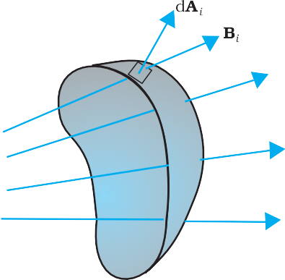where ‘all’ stands for summation over all the area elements d**A***i* comprising the surface and **B***i* is the magnetic field at the area element d**A**i. The SI unit of magnetic flux is weber (Wb) or tesla meter squared (T m2). Magnetic flux is a scalar quantity.

##### FARADAY’S LAW OF INDUCTION

From the experimental observations, Faraday arrived at a conclusion that an emf is induced in a coil when magnetic flux through the coil changes with time. Experimental observations discussed in Section 6.2 can be explained using this concept. The motion of a magnet towards or away from coil C1 in Experiment 6.1 and moving a current-carrying coil C2 towards or away from coil C1 in Experiment 6.2, change the magnetic flux associated with coil C1. The change in magnetic flux induces emf in coil C1. It was this induced emf which caused electric

**FIGURE 6.4** A plane of surface area **A** placed in a uniform magnetic field **B**.

current to flow in coil C1 and through the galvanometer. A plausible explanation for the observations of Experiment 6.3 is as follows: When the tapping key K is pressed, the current in coil C2 (and the resulting magnetic field) rises from zero to a

*i*

**FIGURE 6.5** Magnetic field **B***i* at the *i*th area element. d**A** represents area vector of the *i*th area element.

maximum value in a short time. Consequently, the magnetic

flux through the neighbouring coil C1 also increases. It is the change in magnetic flux through coil C1 that produces an induced emf in coil C1. When the key is held pressed, current in coil C2 is constant. Therefore, there is no change in the magnetic flux through coil C1 and the current in coil C1 drops to zero. When the key is released, the current in C2 and the resulting magnetic field decreases from the maximum value to zero in a short time. This results in a decrease in magnetic flux through coil C1 and hence again induces an electric current in coil C1**\***. The common point in all these observations is that the time rate of change of magnetic flux through a circuit induces emf in it. Faraday stated experimental observations in the form of a law called *Faraday’s law of electromagnetic induction*. The law is stated below.

**\*** Note that sensitive electrical instruments in the vicinity of an electromagnet can be damaged due to the induced emfs (and the resulting currents) when the electromagnet is turned on or off.

###### 207

*The magnitude of the induced* emf *in a circuit is equal to the time rate of change of magnetic flux through the circuit.*

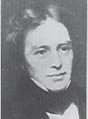

**Michael Faraday [1791–**

**1867]** Faraday made numerous contributions to science, viz., the discovery of electromagnetic induction, the laws of electrolysis, benzene, and the fact that the plane of polarisation is rotated in an electric field. He is also credited with the invention of the electric motor, the electric generator and the transformer. He is widely regarded as the greatest experimental scientist of the nineteenth century.

Mathematically, the induced emf is given by

**  – d*B*

d*t*

(6.3)

The negative sign indicates the direction of ** and hence the direction of current in a closed loop. This will be discussed in detail in the next section.

MICHAEL FARADAY (1791–1867)

In the case of a closely wound coil of *N* turns, change of flux associated with each turn, is the same. Therefore, the expression for the total induced emf is given by

**  – *N* d*B*

d*t*

(6.4)

The induced emf can be increased by increasing the number of turns *N* of a closed coil.

From Eqs. (6.1) and (6.2), we see that the flux can be varied by changing any one or more of the terms **B**, **A** and

**. In Experiments 6.1 and 6.2 in Section 6.2, the flux is changed by varying **B**. The flux can also be altered by changing the shape of a coil (that is, by shrinking it or stretching it) in a magnetic field, or rotating a coil in a magnetic field such that the angle ** between **B** and **A** changes. In these cases too, an emf is induced in the respective coils.

**Example 6.1** Consider Experiment 6.2. (a) What would you do to obtain a large deflection of the galvanometer? (b) How would you demonstrate the presence of an induced current in the absence of a galvanometer?

**Solution**

1. To obtain a large deflection, one or more of the following steps can be taken: (i) Use a rod made of soft iron inside the coil *C*2, (ii) Connect the coil to a powerful battery, and (iii) Move the arrangement rapidly towards the test coil *C*1.
2. Replace the galvanometer by a small bulb, the kind one finds in a

small torch light. The relative motion between the two coils will cause the bulb to glow and thus demonstrate the presence of an induced current.

*In experimental physics one must learn to innovate. Michael Faraday who is ranked as one of the best experimentalists ever, was legendary for his innovative skills.*

###### 208

**Example 6.2** A square loop of side 10 cm and resistance 0.5  is placed vertically in the east-west plane. A uniform magnetic field of

0.10 T is set up across the plane in the north-east direction. The magnetic field is decreased to zero in 0.70 s at a steady rate. Determine the magnitudes of induced emf and current during this time-interval.

**EXAMPLE 6.2**

**EXAMPLE 6.1**

**EXAMPLE 6.2**



**Solution** The angle ** made by the area vector of the coil with the magnetic field is 45°. From Eq. (6.1), the initial magnetic flux is

** = *BA* cos **

 0.1  10–2

2

Wb

Final flux, **min = 0

The change in flux is brought about in 0.70 s. From Eq. (6.3), the magnitude of the induced emf is given by

**  *B*   ** – 0

*t*

*t*

=  1.0 mV 2  0.7

10–3

And the magnitude of the current is

*I*  

* * 10–3 V

*R* 0.5

 2 mA

Note that the earth’s magnetic field also produces a flux through the

loop. But it is a steady field (which does not change within the time span of the experiment) and hence does not induce any emf.

209

**Example 6.3**

A circular coil of radius 10 cm, 500 turns and resistance 2  is placed with its plane perpendicular to the horizontal component of the earth’s magnetic field. It is rotated about its vertical diameter through 180° in 0.25 s. Estimate the magnitudes of the emf and current induced in the coil. Horizontal component of the earth’s magnetic field at the place is 3.0 × 10–5 T.

**Solution**

Initial flux through the coil,

**B (initial)

= *BA* cos 

= 3.0 × 10–5 × ( ×10–2) × cos 0º

= 3 × 10–7 Wb

Final flux after the rotation,

**B (final)

= 3.0 × 10 × ( ×10 ) × cos 180°

= –3 × 10–7 Wb

–5

–2

Therefore, estimated value of the induced emf is,

*t*

= 500 × (6 × 10–7)/0.25

= 3.8 × 10–3 V

*I* = /*R* = 1.9 × 10–3 A

Note that the magnitudes of  and *I* are the estimated values. Their instantaneous values are different and depend upon the speed of rotation at the particular instant.

**  *N* **

**EXAMPLE 6.3**